HOLIDAY LIGHTS DISPLAY DRAWING ENTRY
DUE OCTOBER 1, 2021 5:00 P.M.
Email completed entry to: kaleena@fairgrounds-foundation.org
Or mail to: Fairgrounds Foundation - P O BOX 1806 - Freedom, CA 95019
Open to all children ages 5 to 11
Please print all information with. name and age clearly.

Name _______________________________________________________ Age _____________ Grade ______________
School _______________________________ Teacher _____________________________Guardian _________________
Description of what the drawing is:_____________________________________________________________________

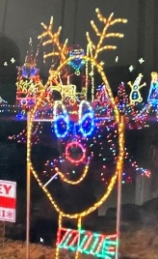 SAMPLE

Drawings can be anything to do with the Holiday Season. The winning drawing must be easy to duplicate in a metal framework with display lights that will be viewed after dark by visitors. A simple design, like the above sample, is best.
There will be one (1) drawing selected and duplicated by the Holiday Lights Committee at NO expense to the entrant
and will be on display for the entire 2021 Holiday Lights event. The student's name and age will be on a special sign posted by the lit display.
During the 2021 Holiday Light walk-thru, the student and a parent or guardian will be available from 5:00 - 9:00pm on Friday, Dec 3 and Saturday, Dec 4 to meet the Holiday Lights walk-thru visitors.
The parents or guardians of the selected student will sign an authorization release for TV and promotional purposes.

